Task 1: Create a comparison table listing at least 4 key features of RADIUS and TACACS+ side by side, highlighting which protocol supports each feature.
RADIUS vs. TACACS+ Protocol Comparison
Key Feature | RADIUS (Remote Authentication Dial-In User Service) | TACACS+ (Terminal Access Controller Access-Control System Plus)
Architecture Framework | Combined: Blends Authentication and Authorization into single profile exchanges. | Separated: Fully splits Authentication, Authorization, and Accounting into distinct processes.
Transport Layer Security | UDP-based: Uses UDP ports 1812/1813; encrypts only the password field within packets. | TCP-based: Uses TCP port 49; provides reliable connections and encrypts the entire packet payload.
Device Command Authorization | Poor/Basic: Lacks the ability to dynamically authorize specific, granular command-line strings | Excellent: Allows granular, command-by-command authorization for network administration tasks.
Primary Use-Case Focus | Network Access: Tailored for end-user network access (e.g., Campus Wi-Fi, VPNs, ISP connections). | Device Management: Tailored for administrator access to network hardware (e.g., switches, routers, firewalls).

Task 2: Draw a step-by-step flow diagram showing the RADIUS authentication process for a user logging in to a public WiFi hotspot, labeling each communication step between the client, network device, and RADIUS server.

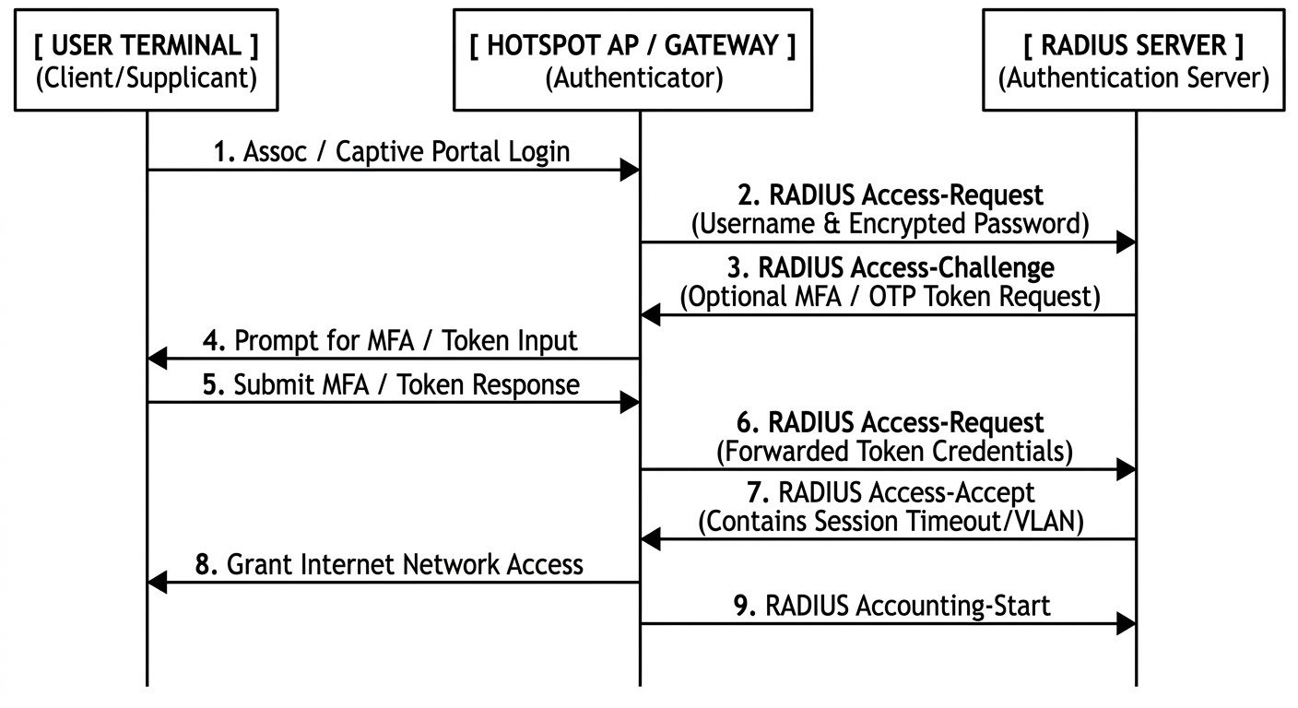
Description of Each Step
Association / Portal Login: The user's device associates with the open Wi-Fi network and is redirected to a captive portal page where they type in their credentials (such as an email, phone number, or purchased voucher code).
Access-Request (Initial): The Hotspot Access Point (AP) acts as the network authenticator. It packages the user's input, encrypts the sensitive fields using a shared secret key, and sends a UDP-based Access-Request packet to the central RADIUS server.
Access-Challenge: If the network requires multi-factor authentication (MFA), a secondary authentication check, or an extra step like an OTP (One-Time Password) confirmation code, the RADIUS server responds with an Access-Challenge.
Prompt for Token: The local Hotspot network device translates this challenge into a web page form on the user's browser, prompting them to check their text messages or authenticator app for the security token.
Submit Token: The user submits the required OTP code back to the local public Wi-Fi network gateway.
Access-Request (Secondary): The Hotspot infrastructure takes the OTP response data and forwards it back to the RADIUS server inside a new Access-Request packet.
Access-Accept: The RADIUS server verifies the token against the profile database. Finding it valid, it returns an Access-Accept packet. This packet also returns authorization metrics like maximum download speeds, bandwidth limits, or session expiration timers.
Grant Network Access: The Hotspot device changes the user's firewall state from restricted to open, allowing their device to freely browse the internet.
Accounting-Start: Immediately upon unlocking internet access, the Hotspot gateway transmits an Accounting-Start message to log the user's connection timestamp, ensuring accurate tracking of active hotspot sessions.
Task 3: List 3 real-world use cases where TACACS+ is preferred over RADIUS, and briefly explain why TACACS+ is better suited for each scenario.
1. Granular Command-Level Authorization for Network Administrators
Scenario: A large telecommunications provider or cloud data center needs to control what actions different tiers of network engineers can perform on central routers and switches.
Why TACACS+ is better suited: TACACS+ separates authentication from authorization. Because of this separation, it can validate every single command an administrator types in real-time. For example, a senior engineer can be authorized to run all configuration commands (config term), while a junior technician's access can be restricted strictly to read-only troubleshooting commands (show commands). RADIUS cannot authorize individual commands dynamically; it can only deliver pre-defined user profiles or privilege levels upon login.
2. Secure Telemetry and Full-Packet Encryption for Financial Data Centers
Scenario: A bank or financial services institution must meet strict compliance standards (like PCI-DSS) that require all internal administrative traffic to be completely secure from packet sniffing.
Why TACACS+ is better suited: RADIUS only encrypts the user password within its packets, leaving the username, attributes, and accounting data visible in cleartext over the wire. TACACS+ uses TCP and encrypts the entire body of the packet, hiding usernames, commands executed, and device responses. This full-payload encryption ensures that an attacker performing a packet capture inside a sensitive financial network cannot harvest structural data or admin names.
3. High-Reliability Automated Network Management (DevOps & CI/CD Pipelines)
Scenario: An enterprise uses automated network automation scripts (like Ansible, Netmiko, or Python) to push configuration changes to thousands of routers and switches simultaneously during a maintenance window.
Why TACACS+ is better suited: Network automation scripts generate a high volume of simultaneous connection requests that must be executed reliably. Because TACACS+ relies on TCP (Port 49), it establishes a reliable, connection-oriented session for each device interaction. This guarantees that configuration steps are acknowledged and verified. RADIUS relies on UDP (Ports 1812/1813), which is connectionless and prone to dropping packets under heavy load, potentially causing automated scripts to time out or leave switches partially configured.
Task 4: Given a scenario where a user tries to log into a network device but fails authentication, describe how RADIUS and TACACS+ would handle the logging and response differently. Focus on how each protocol manages accounting and command authorization.
When a user attempts to log into a network device (such as a core switch or router) and fails authentication, RADIUS and TACACS+ handle the resulting error architecture, message formatting, and log tracking in fundamentally different ways.The core variation stems from their architectural design: RADIUS combines its functions into a single profile transaction, while TACACS+ uses decoupled, distinct components for authentication, authorization, and accounting.
1. RADIUS (Remote Authentication Dial-In User Service)
How it handles the Authentication Failure and Response:
The Response: The RADIUS server validates the inbound credentials against its directory database. Upon finding a bad password or invalid username, it immediately generates a single Access-Reject packet and sends it back to the switch.
The Client Experience: The switch drops the connection or reprompts the user. Because authentication failed, no user profile or configuration privileges are passed back.
Impact on Accounting and Command Authorization:
Accounting Management: By protocol standard, no accounting record is generated for failed logins in RADIUS. RADIUS accounting relies on an Accounting-Start packet, which is only triggered after a successful connection handshake (Access-Accept). The server logs the failed authentication attempt inside its internal security/event logs, but a structured network accounting audit trail does not exist for this session.
Command Authorization: Command authorization is a non-factor. Because the transaction was terminated during the initial combined phase, no authorization parameters were ever delivered to the network device. The user is completely blocked from accessing the command-line interface (CLI).

2. TACACS+ (Terminal Access Controller Access-Control System Plus)
How it handles the Authentication Failure and Response:
The Response: The network switch opens a reliable TCP session with the TACACS+ server. The server evaluates the credentials and sends back an authentication packet explicitly containing a FAIL status attribute.
The Client Experience: The network switch reads the FAIL state packet, denies access to the terminal interface, and closes the TCP session.
Impact on Accounting and Command Authorization:
Accounting Management: Unlike RADIUS, TACACS+ natively generates detailed accounting records for failed authentication attempts. Because accounting runs independently from authentication, the TACACS+ server writes a dedicated "Failed Login" accounting log payload. This log captures the complete transaction: the exact username typed, the source IP address, the terminal line used (e.g., VTY 0), the target device identifier, a timestamp, and an explicit reason code indicating an authentication failure.
Command Authorization: No command authorization occurs because the session never reaches the separate authorization phase. However, because TACACS+ separates these steps, the network device can be configured with a local fallback policy. If a user fails TACACS+ server authentication, the device can block CLI commands entirely, or fallback to local device database authentication to allow emergency access to troubleshooting commands.
Task 5: Use ChatGPT or another AI tool to generate a sample RADIUS configuration snippet for a Cisco router, then review the output and list any changes you would make to adapt it for a college campus WiFi setup.
Campus Wi-Fi Security Audit & Custom Modifications
! Enable AAA globally
aaa new-model

! Configure Authentication for login
aaa authentication login default group radius local

! Define the RADIUS server profile
radius server CAMPUS-AAA
address ipv4 192.168.1.50 auth-port 1812 acct-port 1813
key cisco123

! Apply RADIUS to lines
line vty 0 4
login authentication default
Campus Wi-Fi Security Audit & Custom Modifications
While the configuration above works for a basic lab, it contains major security vulnerabilities and scaling limitations that make it unsuitable for a college campus environment.
To adapt it for a sprawling campus network with thousands of students, staff, and roaming devices, the following five modifications must be made:
1. Replace Weak Shared Secrets
The AI Output: key cisco123
The Campus Reality: cisco123 is a default, easily brute-forced key. On a campus where computer science students and external guests actively probe the network, a weak key exposes authentication traffic to offline cracking.
The Fix: Generate a strong, random, alphanumeric shared secret of at least 22 characters.
2. Implement 802.1X Wireless Authentication (Dot1x)
The AI Output: aaa authentication login default group radius local
The Campus Reality: The AI configured authentication strictly for administrative CLI login access (login default). A campus Wi-Fi deployment requires an infrastructure-wide framework that intercepts wireless client devices trying to associate with the university Access Points.
The Fix: Add a dedicated 802.1X wireless authentication list to negotiate EAP protocols (like PEAP or EAP-TLS) for students and faculty.
3. Enable Network Accounting for Bandwidth and Compliance Tracking
The AI Output: Completely omitted network accounting commands.
The Campus Reality: Under local regulatory frameworks and university compliance rules, IT departments must keep audit trails of network sessions. Accounting logs track who logged in, when, from which Access Point, and how much data they consumed.
The Fix: Add AAA accounting commands to track network usage data.
4. Add Secondary Failover Servers for High Availability
The AI Output: Configured only a single server instance (192.168.1.50).
The Campus Reality: A single server represents a catastrophic single point of failure. If that machine crashes during an exam period or registration week, the entire campus loses internet access.
The Fix: Configure a secondary (backup) AAA server for redundancy and load balancing.

